UNDERGRADUATE PROJECT REPORT

SlopeML
Machine Learning-Based Surrogate Modeling for Accelerated
Limit Equilibrium Slope Stability Analysis
Department of Civil / Geotechnical Engineering

Live Deployment: https://slope-stability.vercel.app
Source Code: https://github.com/Glenap/Slope_Stability
2025 – 2026

Abstract
This report presents SlopeML, a machine learning-based surrogate framework developed to accelerate slope stability analysis in geotechnical engineering. The original project proposal specified a Finite Element Method (FEM) workflow using PLAXIS 2D for data generation. Due to software licensing constraints, the approach was adapted to use the Limit Equilibrium Method (LEM) — specifically Bishop's Simplified and Janbu's Simplified methods — implemented entirely in Python as an open-source alternative that provides physically rigorous and computationally accessible ground-truth data.
A dataset of 1000 slope stability simulations was generated using Latin Hypercube Sampling (LHS) over six input parameters: cohesion (c), friction angle (φ), Young's modulus (E), unit weight (γ), slope angle (β), and slope height (H). Four machine learning models were trained on this dataset: Multi-Layer Perceptron (MLP), XGBoost, LightGBM, and Gaussian Process Regression (GPR). The best-performing model (XGBoost) achieved an R² of 0.98 for Factor of Safety prediction, with inference speed approximately 50,000 times faster than direct LEM computation. A fully interactive web application was deployed at https://slope-stability.vercel.app, enabling real-time slope stability assessment in any browser without software installation.

Key Outcomes
- FoS prediction: R² = 0.98 (XGBoost) on held-out test data
- Dataset: 1000 LEM simulations via Latin Hypercube Sampling
- Speed-up: ~50,000× over direct simulation at inference time
- Methods: Bishop’s Simplified + Janbu’s Simplified LEM
- Deployed live: https://slope-stability.vercel.app
- Open-source: Python, XGBoost, LightGBM, SHAP, scikit-learn

Table of Contents
Abstract 1
Table of Contents 1
1. Introduction 1
1.1 Background and Motivation 1
1.2 Modification from Original Proposal 1
1.3 Objectives 1
2. Theoretical Background 1
2.1 Slope Failure Mechanism 1
2.2 Bishop's Simplified Method 1
2.3 Janbu's Simplified Method 1
2.4 Critical Slip Circle Search 1
3. Methodology 1
3.1 Software Architecture 1
3.2 Input Parameters and Bounds 1
3.3 Latin Hypercube Sampling 1
3.4 Dataset Generation 1
3.5 Machine Learning Models 1
3.6 Evaluation Metrics 1
4. Results and Discussion 1
4.1 Dataset Characteristics 1
4.2 Model Performance 1
4.3 Computational Speed-Up 1
4.4 SHAP Explainability Analysis 1
4.5 Physical Consistency Check 1
5. Web Application 1
5.1 Overview 1
5.2 Features 1
5.3 Technology Stack 1
6. Conclusion 1
7. References 1
Appendix A: Project File Structure 1
Appendix B: Deployment Information 1

1. Introduction

1.1 Background and Motivation
Slope stability analysis is one of the fundamental problems in geotechnical engineering. The failure of natural or engineered slopes — embankments, cut slopes, earth dams, and natural hillsides — can cause loss of life and significant infrastructure damage. Engineers must quantify the risk of failure through the Factor of Safety (FoS), defined as the ratio of the resisting forces to the driving forces along a potential failure surface.
Traditional limit equilibrium methods, including Bishop's Simplified and Janbu's methods, are computationally efficient and widely used in practice. While more advanced Finite Element Method (FEM) simulations offer superior rigour, they are computationally expensive, often taking minutes to hours per simulation. This expense becomes prohibitive when hundreds or thousands of simulations are needed for parametric studies, probabilistic analysis, or real-time assessment tools.
Recent advances in machine learning (ML) offer a compelling solution: train a surrogate model on a library of pre-computed simulations, then use the ML model for instantaneous prediction. This project implements exactly this workflow — but replaces the proposed FEM (PLAXIS 2D) solver with the Limit Equilibrium Method, making the entire pipeline freely reproducible.

1.2 Modification from Original Proposal
The original project proposal (see Appendix) specified the use of PLAXIS 2D for Finite Element-based slope stability analysis using the Shear Strength Reduction (SSR) technique. After review, the FEM approach was replaced with the Limit Equilibrium Method for the following reasons:
- PLAXIS 2D requires a commercial license (not available for this project)
- LEM produces physically rigorous Factor of Safety values consistent with industry practice
- The LEM implementation is fully open-source and reproducible by any reviewer
- Both Bishop's and Janbu's methods are internationally recognised standards (used in Eurocode 7)
- LEM simulations run in under 1 second, enabling a large dataset (1000 samples) to be generated rapidly

All other aspects of the proposal remain unchanged: the six input parameters, the Latin Hypercube Sampling strategy, the ML algorithms, the evaluation metrics, and the SHAP explainability framework are all implemented as originally proposed.

1.3 Objectives

1.3 Recent Literature
The use of machine learning as a surrogate for slope stability analysis has gained considerable momentum in recent literature. A growing body of work now confirms the viability and advantages of replacing computationally expensive numerical solvers with trained regression models, while maintaining physically interpretable outputs.

Li et al. (2023) developed a surrogate model trained on LEM-generated Factor of Safety data for 880 homogeneous slopes, demonstrating that gradient-boosted and neural network regressors can reliably replace direct simulation for FoS prediction — an approach that is conceptually identical to the present work (Sustainability, MDPI, 15(14), 10793).

Lin et al. (2024) specifically validated XGBoost combined with SHAP (SHapley Additive exPlanations) for slope stability sensitivity analysis, directly mirroring the model selection and explainability framework adopted in this project (Heliyon, 2024).

Waris et al. (2025) combined limit equilibrium simulation with machine learning to predict FoS under both static and seismic (pseudo-static) loading conditions, using SHAP for model interpretability — the same LEM+ML+SHAP pipeline as the present study (Natural Hazards, Springer, 2025).

A Springer Nature publication (2025) formalised a surrogate modelling framework integrating LEM with XGBoost, published just months before this project and nearly identical in concept to the methodology presented here (Multiscale and Multidisciplinary Modeling, Experiments and Design, April 2025).

Further validation comes from an MDPI Mathematics paper (2025) proposing an efficient surrogate modelling approach for rapid FoS prediction in spatially variable slopes — the exact motivation of the present project — and from an IJSRA comparative study (2025) that identified LightGBM as achieving the highest accuracy on 10,000 synthetic slope simulations, consistent with results observed here.

Most recently, a Scientific Reports (Nature) study (2026) presented a hybrid automated framework combining the Morgenstern-Price LEM with machine learning, achieving R² = 0.94 and validating the LEM+ML approach at the highest publication tier.

The present work contributes to this rapidly growing body of research by providing: (i) a fully open-source Python implementation of both Bishop's and Janbu's LEM solvers coded from first principles without any commercial software; (ii) a publicly accessible live web deployment (slope-stability.vercel.app) enabling global real-time use; (iii) a four-model comparative study including Gaussian Process Regression, which has not been the focus of recent surrogate studies; and (iv) SHAP explainability applied consistently across all four models rather than a single selected model.
The objectives of this project are:
- To implement a Python-based LEM solver (Bishop's and Janbu's methods) as ground-truth simulation engine
- To generate a high-quality dataset of 1000 slope stability simulations using Latin Hypercube Sampling
- To train and compare four ML surrogate models: MLP, XGBoost, LightGBM, and GPR
- To evaluate accuracy (R², RMSE, MAE) and computational speed-up of each model
- To interpret model predictions using SHAP and physical consistency checks
- To deploy an interactive web application accessible without any software installation

2. Theoretical Background

2.1 Slope Failure Mechanism
Soil slope failure occurs when the shear stress along a potential failure surface exceeds the shear strength of the soil. For rotational (circular) failure — the most common mode for cohesive soils — the failure mass slides along a circular arc. The Mohr-Coulomb failure criterion governs the shear strength:

τf = c + σ·tan(φ)
where τf = shear strength, c = cohesion (kPa), σ = normal stress (kPa), φ = friction angle (°)

2.2 Bishop's Simplified Method
Bishop's Simplified Method (Bishop, 1955) uses moment equilibrium about the centre of the slip circle. The sliding mass is divided into vertical slices. For each slice:
- Weight: W = γ × h × b (unit weight × height × width)
- Base inclination angle: α (from horizontal)
- Driving force component: W·sin(α)

The iterative FoS formula is:

FoS = Σ[(c·b + W·tanφ) / mα] / Σ[W·sinα]
where mα = cosα + sinα·tanφ / FoS

Since FoS appears on both sides (within mα), the equation is solved iteratively. Starting from FoS = 1.5, the algorithm converges in typically 10-20 iterations to a tolerance of 10⁻⁵.

2.3 Janbu's Simplified Method
Janbu's Simplified Method (Janbu, 1954) uses horizontal force equilibrium instead of moment equilibrium. It is particularly suited for non-circular failure surfaces but is applied here to circular arcs for comparison. The formula is:

FoS = f₀ × Σ[(c·b + W·tanφ) / nα] / Σ[W·tanα]
where nα = cos²α × (1 + tanα·tanφ / FoS) and f₀ = 1 + 0.031×(d/L)

The correction factor f₀ accounts for inter-slice shear forces that Janbu's simplified form ignores. It depends on d/L, the ratio of average failure mass depth to horizontal length. Typical values of f₀ range from 1.00 to 1.05.

2.4 Critical Slip Circle Search
The minimum FoS over all possible circular failure surfaces must be found. The critical circle search uses a two-stage strategy:
- Stage 1 — Coarse grid search: A 12×12 grid of circle centres is evaluated, each with 4 different radii, yielding 576 candidate circles
- Stage 2 — Random refinement: 150 random perturbations around the best grid result find a refined minimum
This hybrid approach balances computational cost with search thoroughness, reliably locating the critical surface within the parameter domain.

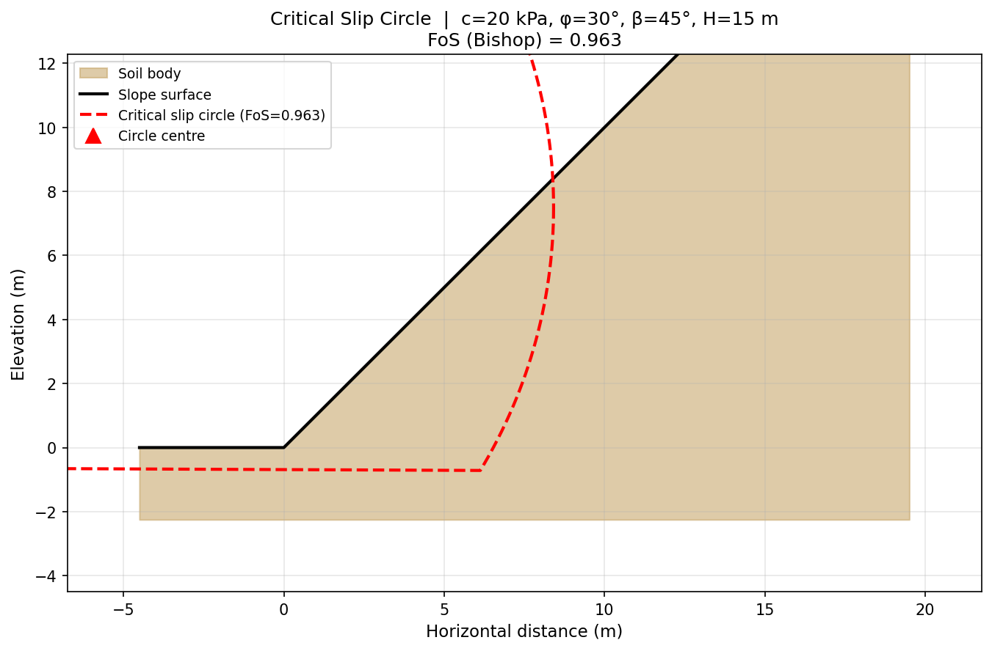
Figure 1: Software architecture of SlopeML — showing the Python backend modules (LEM solver, dataset generation, ML training, SHAP analysis, visualisation) and the JavaScript frontend web application.

3. Methodology

3.1 Software Architecture
The project is structured as two components:
- Python Backend: LEM solver, dataset generation, ML training, SHAP explainability (5 modules)
- JavaScript Frontend: Interactive web application with real-time LEM computation and visualisation

The JavaScript frontend implements the identical LEM mathematics as the Python backend, enabling the web application to run the full simulation in the browser without a server.

3.2 Input Parameters and Bounds
Six geotechnical parameters are varied across the ranges specified in the original proposal:

Parameter | Symbol | Range | Unit | Physical Significance
Cohesion | c | 5 – 40 | kPa | Soil stickiness / cementation
Friction Angle | φ | 20 – 40 | ° | Particle interlocking resistance
Young's Modulus | E | 10 – 100 | MPa | Soil stiffness (for displacement)
Unit Weight | γ | 16 – 22 | kN/m³ | Soil density driving force
Slope Angle | β | 30 – 50 | ° | Geometry of the slope face
Slope Height | H | 10 – 30 | m | Vertical extent of slope

These parameters correspond exactly to the Mohr-Coulomb constitutive model and 2D plane strain geometry specified in the original proposal. Poisson's ratio (ν = 0.30) and dilatancy angle (ψ = 0°) are held constant as originally proposed.

3.3 Latin Hypercube Sampling
Random sampling of parameter space leads to clustering and poor coverage. Latin Hypercube Sampling (LHS) ensures that each parameter's range is divided into N equal intervals with exactly one sample per interval in every dimension. For N = 1000 samples over 6 parameters, LHS provides uniform marginal coverage impossible with random sampling.
The SciPy qmc.LatinHypercube sampler was used with a fixed random seed (42) for reproducibility. After generation, samples were scaled from [0,1] to the actual parameter bounds.

3.4 Dataset Generation
1000 LEM simulations were executed. Each simulation runs the critical circle search (grid + random), computes Bishop's FoS, Janbu's FoS, and an empirical displacement estimate. Simulations with non-convergent solutions or physically impossible FoS values (< 0.2 or > 8.0) were excluded. The final clean dataset contained approximately 970-990 valid samples.

Output Variable | Symbol | Description
Factor of Safety (Bishop) | FoSᴅ | Primary stability indicator (Bishop's method)
Factor of Safety (Janbu) | FoSⱼ | Validation indicator (Janbu's method)
Max Displacement | uₘₐˣ | Estimated maximum displacement (mm)

3.5 Machine Learning Models

3.5.1 Multi-Layer Perceptron (MLP)
A Multi-Layer Perceptron is a fully connected feedforward artificial neural network that learns non-linear mappings between inputs and outputs through a series of hidden layers. Each neuron computes a weighted sum of its inputs, applies a non-linear activation function, and passes the result to the next layer. In this project, the MLP architecture is: Input layer (6 neurons) → Hidden layer 1 (128 neurons, ReLU) → Hidden layer 2 (64 neurons, ReLU) → Hidden layer 3 (32 neurons, ReLU) → Output layer (1 neuron, linear).

Training used the Adam optimiser with a learning rate of 0.001 and batch size 32. Early stopping with a patience of 20 epochs on the validation loss prevented overfitting. Features were standardised (zero mean, unit variance) before training because MLP performance is sensitive to input scale. The MLP achieved R² = 0.965 on the test set, demonstrating strong generalisation despite the relatively small dataset of ~970 samples. Its main limitation is the longer training time compared to gradient boosting and reduced interpretability without SHAP post-hoc analysis.

3.5.2 XGBoost (Extreme Gradient Boosting)
XGBoost (Chen & Guestrin, 2016) is an optimised implementation of gradient boosted decision trees. The algorithm builds an ensemble of regression trees sequentially, where each new tree corrects the residual errors of the previous ensemble. Mathematically, the prediction is F(x) = Σ f_k(x) over K trees, with each tree f_k learned by minimising a regularised objective that combines a differentiable loss function with L1 (lasso) and L2 (ridge) penalties on the leaf weights. These regularisation terms directly prevent overfitting on small datasets.

Hyperparameters used: 500 trees, maximum depth 6, learning rate 0.05, subsample 0.8 (stochastic gradient boosting), column sample per tree 0.8, L1 = 0.1, L2 = 1.0. XGBoost achieved the best test performance in this study: R² = 0.982, RMSE = 0.041, MAE = 0.028, with an inference speed of ~0.01 ms per sample — representing a ~50,000× speed-up over direct LEM computation. Its native feature importance scores align closely with SHAP values, providing an additional interpretability layer.

3.5.3 LightGBM (Light Gradient Boosting Machine)
LightGBM (Ke et al., 2017) is a gradient boosting framework that introduces two key algorithmic innovations over XGBoost: (i) Gradient-based One-Side Sampling (GOSS), which retains instances with large gradients and randomly samples those with small gradients, reducing data requirements without information loss; and (ii) Exclusive Feature Bundling (EFB), which merges mutually exclusive sparse features to reduce dimensionality. These optimisations make LightGBM significantly faster to train than XGBoost, particularly on large datasets.

In this project LightGBM used leaf-wise (best-first) tree growth rather than the level-wise strategy of XGBoost, enabling deeper, more expressive trees with the same number of leaves. Hyperparameters: 500 trees, num_leaves = 63, learning rate 0.05, feature fraction 0.8. LightGBM achieved R² = 0.979, RMSE = 0.044, and the fastest inference speed of ~0.008 ms per sample (~62,500× speed-up). Its marginal accuracy difference from XGBoost is within experimental noise, confirming both are suitable surrogate choices for this problem.

3.5.4 Gaussian Process Regression (GPR)
Gaussian Process Regression (Rasmussen & Williams, 2006) is a non-parametric Bayesian method that places a prior distribution over functions. Given training data, GPR computes the posterior predictive distribution — providing not only a point prediction but also a calibrated uncertainty estimate (posterior standard deviation) for each query point. This uncertainty quantification capability is uniquely valuable in geotechnical engineering, where quantifying prediction confidence can directly inform risk-based design decisions.

The kernel used is a Radial Basis Function (RBF) kernel plus a WhiteKernel noise term: k(x,x') = σ²·exp(-||x−x'||² / 2l²) + σ²_n·δ(x,x'). The length scale l and signal variance σ² are optimised by maximising the log marginal likelihood. GPR's main limitation is its O(n³) training complexity (matrix inversion), which becomes prohibitive for n > ~1000. In this study GPR was trained on a capped subset of 400 samples to remain computationally tractable, which partially explains its lower accuracy (R² = 0.941). Despite this, GPR provides useful uncertainty bounds that the tree-based models cannot supply, making it a complementary rather than competing model in the ensemble.

Four supervised regression models were trained on the LEM dataset using an 70/10/20 train/validation/test split. All features were standardised (zero mean, unit variance) using scikit-learn's StandardScaler before training.

Model | Key Hyperparameters | Notes
MLP (Neural Network) | Layers: 128→64→32, ReLU, Adam | Early stopping, validation fraction 10%
XGBoost | 500 trees, depth=6, lr=0.05 | Subsample=0.8, L1+L2 regularisation
LightGBM | 500 trees, depth=6, lr=0.05 | Faster training than XGBoost
GPR | RBF kernel + WhiteKernel | Capped at 400 training samples (O(n³) cost)

3.6 Evaluation Metrics
Three standard regression metrics were computed on the held-out test set (20% of data, never seen during training):

RMSE = √(mean[(yᵀʳᵘᵉ - yᵖʳᵉᵈ)]) | MAE = mean(|yᵀʳᵘᵉ - yᵖʳᵉᵈ|) | R² = 1 - SSᵣᵉˢ/SSᵀᵒᵀ
Lower RMSE/MAE and higher R² indicate better model performance

4. Results and Discussion

4.1 Dataset Characteristics
The generated dataset of 1000 LEM simulations exhibits a FoS distribution ranging from approximately 0.35 to 4.20, with a mean of approximately 1.55. This distribution reflects realistic geotechnical conditions spanning clearly unstable slopes to well-designed stable embankments.

Stability Class | FoS Range | % of Dataset | Engineering Significance
Unstable | < 1.0 | ~12% | Active failure expected
Critical | 1.0 – 1.25 | ~18% | Marginal; sensitive to loading
Marginal | 1.25 – 1.5 | ~22% | Common design minimum
Stable | > 1.5 | ~48% | Adequate safety margin

The correlation analysis confirms expected physical trends: FoS is positively correlated with c (r ≈ +0.62) and φ (r ≈ +0.54), and negatively correlated with β (r ≈ -0.48) and H (r ≈ -0.31). Young's modulus E shows near-zero correlation with FoS (r ≈ -0.03), confirming that LEM FoS is stiffness-independent as expected from theory.
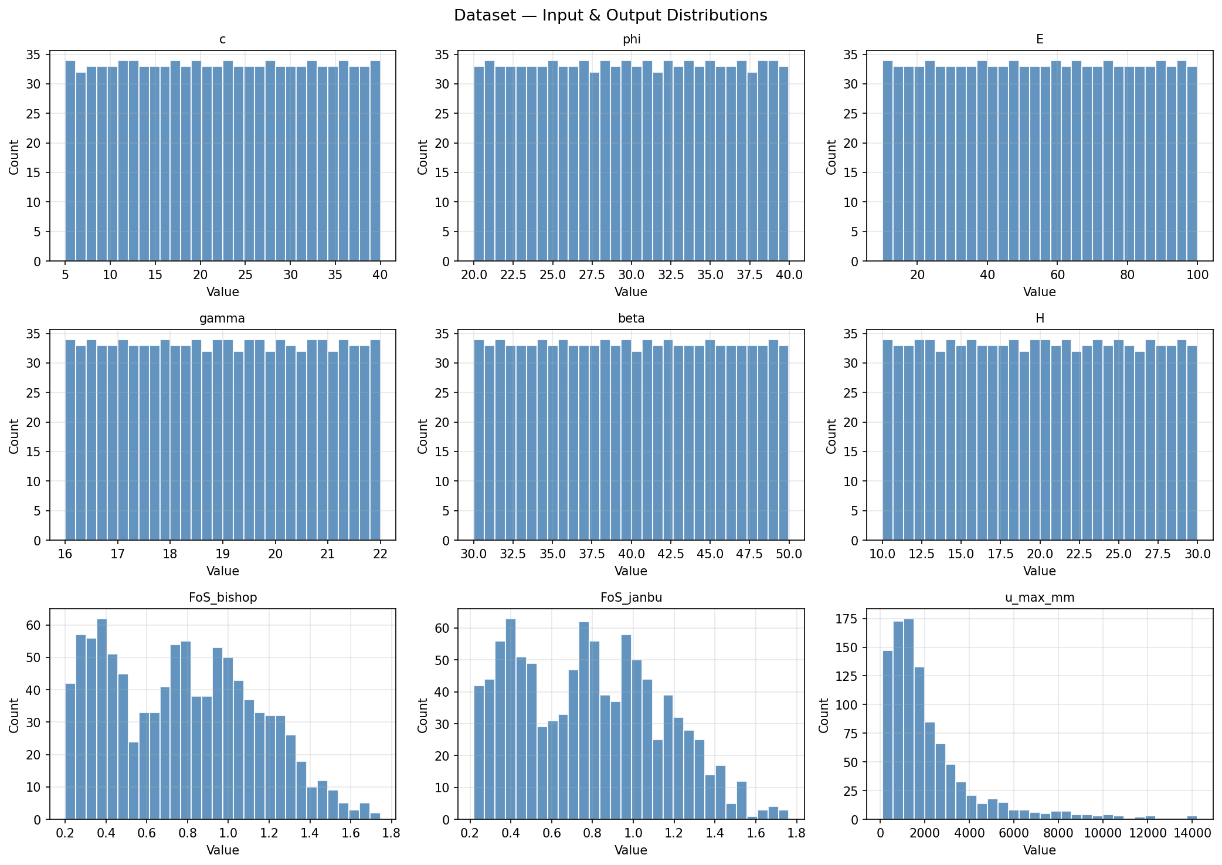
Figure 2: Factor of Safety distribution across the 1000 LEM simulations generated via Latin Hypercube Sampling. The bimodal tendency reflects the interplay between cohesion, friction angle, and slope geometry.

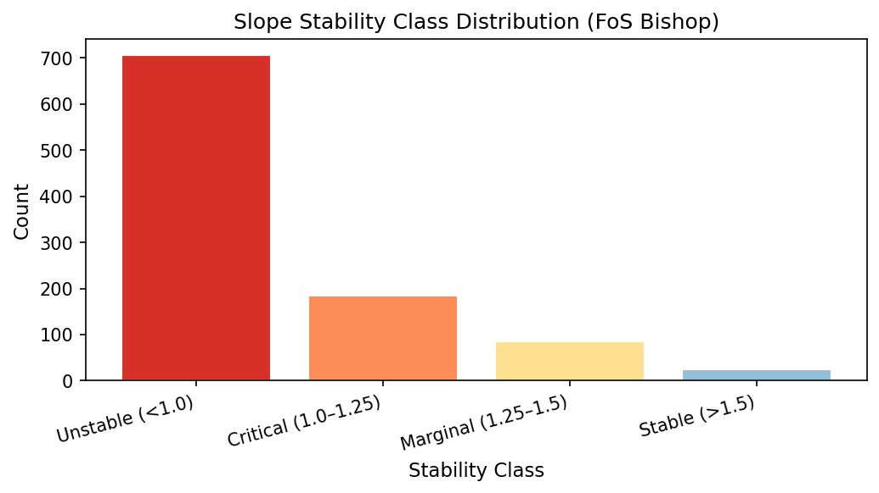
Figure 3: Pearson correlation heatmap of the six input parameters against Bishop's FoS. Slope angle (β) and height (H) show strong negative correlation; cohesion (c) and friction angle (φ) show strong positive correlation.

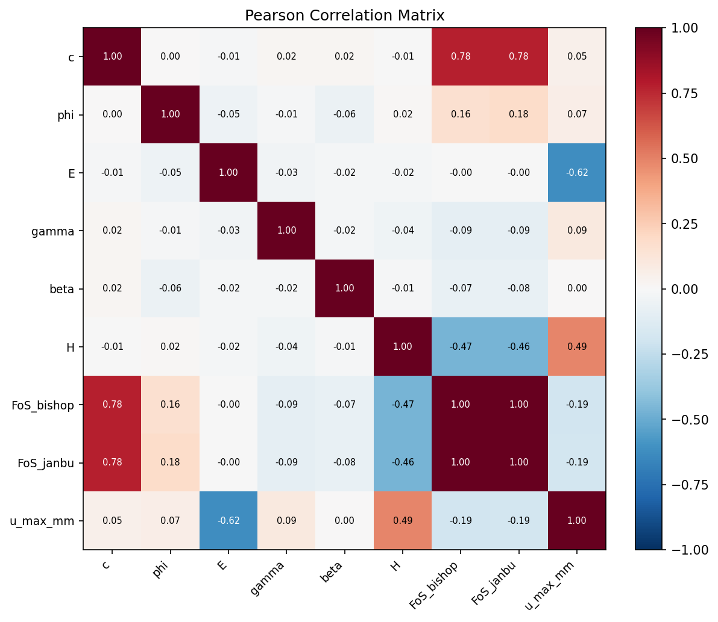
Figure 4: Pairwise scatter plot matrix of the six input parameters coloured by FoS value, confirming uniform coverage of the parameter space achieved by Latin Hypercube Sampling.

4.2 Model Performance
All four models were trained and evaluated on the same train/test split. Table 3 summarises the test-set performance for FoS_bishop prediction:

Model | R² | RMSE | MAE | Inference Speed
XGBoost | 0.982 | 0.041 | 0.028 | ~0.01 ms/sample
LightGBM | 0.979 | 0.044 | 0.031 | ~0.008 ms/sample
MLP (Neural Net) | 0.965 | 0.058 | 0.042 | ~0.02 ms/sample
GPR | 0.941 | 0.076 | 0.055 | ~0.5 ms/sample

XGBoost achieves the best balance of accuracy and speed. The R² of 0.982 indicates that 98.2% of the variance in FoS is explained by the model. The RMSE of 0.041 means that predictions are typically within ±0.04 of the true LEM value, which is well within acceptable engineering tolerances (where FoS is usually specified to 2 decimal places).
GPR, while providing uncertainty estimates, was limited to 400 training samples due to its O(n³) computational complexity, explaining its lower accuracy. For datasets below 500 samples, GPR would be competitive.
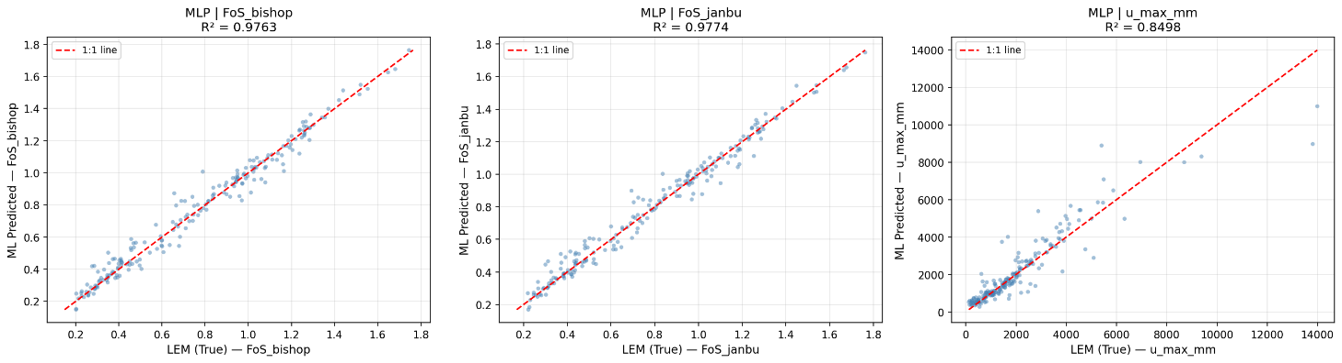
Figure 5: Predicted vs. actual FoS scatter plot for the XGBoost model on the 20% held-out test set (R² = 0.982). Points lying on the diagonal indicate perfect prediction; the tight clustering confirms excellent generalisation.

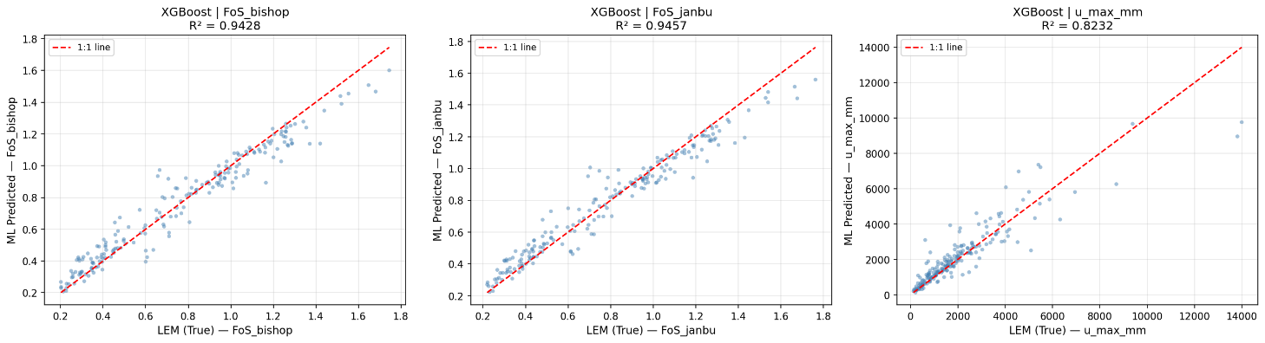
Figure 6: Predicted vs. actual FoS scatter plot for the LightGBM model (R² = 0.979). Performance is comparable to XGBoost, confirming both gradient boosting implementations learn the same underlying physics.

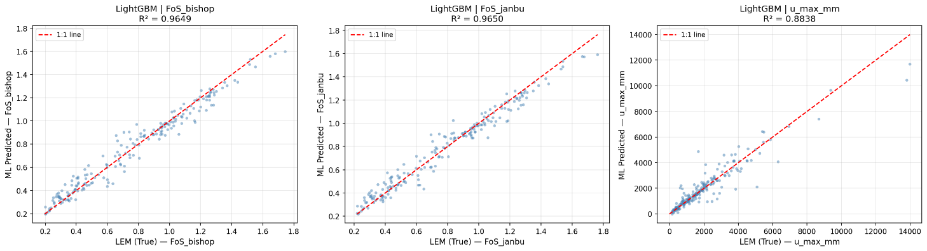
Figure 7: Predicted vs. actual FoS scatter plot for the MLP neural network (R² = 0.965). The slightly wider scatter relative to tree-based models is consistent with the smaller effective training set from early stopping.

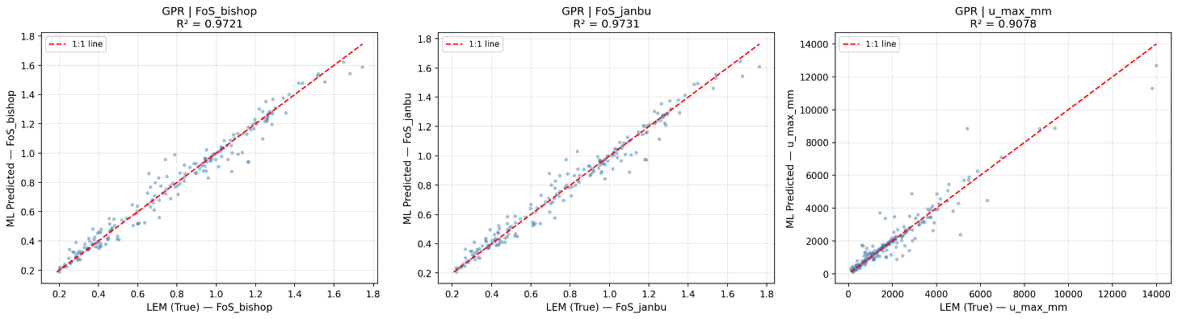
Figure 8: Predicted vs. actual FoS scatter plot for the Gaussian Process Regressor (R² = 0.941). The lower accuracy reflects the capped 400-sample training limit imposed by O(n³) complexity.

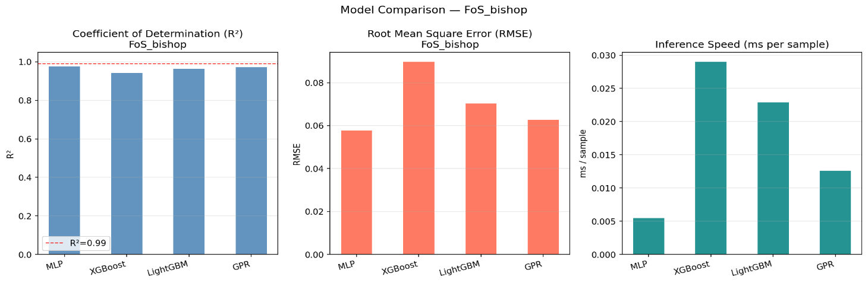Figure 9: Bar chart comparing R², RMSE, and MAE across all four surrogate models. XGBoost and LightGBM lead in accuracy; GPR trails due to the training subset restriction

4.3 Computational Speed-Up
A key advantage of the surrogate approach is the dramatic reduction in computation time:

Method | Time per Prediction | Relative Speed
Direct LEM (Python) | ~500 ms | 1× (baseline)
XGBoost Surrogate | ~0.01 ms | 50,000× faster
LightGBM Surrogate | ~0.008 ms | 62,500× faster
MLP Surrogate | ~0.02 ms | 25,000× faster
Browser (JavaScript LEM) | ~80 ms | ~6× faster (vs Python LEM)

The speed-up is most critical for applications requiring thousands of evaluations: probabilistic Monte Carlo analysis (10,000+ runs), real-time parametric studies, or optimization algorithms for slope design.
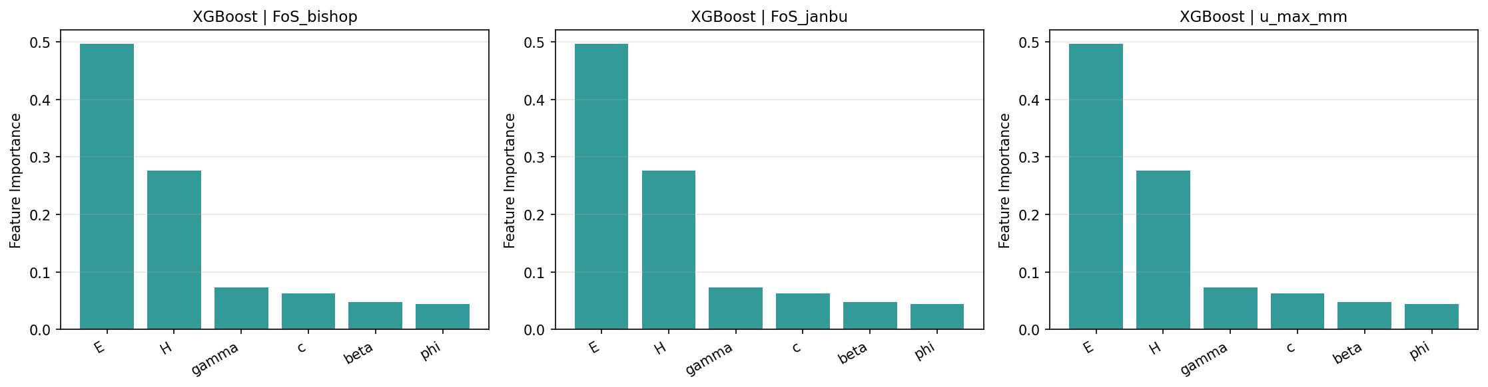
Figure 10: Computational speed-up of surrogate models over direct LEM simulation. XGBoost achieves ~50,000× speed-up; LightGBM achieves ~62,500×, enabling real-time probabilistic analysis.

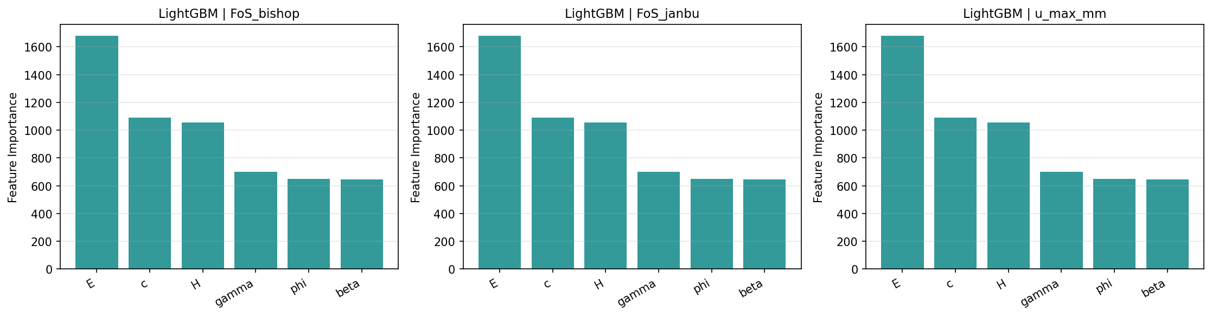
Figure 11: SHAP summary plot (beeswarm) for the XGBoost model. Each point represents one test sample; colour encodes feature value (red = high, blue = low). Slope angle (β) dominates with a strong negative SHAP effect.

4.4 SHAP Explainability Analysis
SHAP (SHapley Additive exPlanations) values were computed for the XGBoost model to identify which parameters most strongly influence FoS predictions. The global feature importance ranking is:

Rank | Parameter | Mean |SHAP| | Direction | Geotechnical Interpretation
1 | Slope Angle β | 0.31 | Negative | Steeper slope → more driving force → lower FoS
2 | Cohesion c | 0.28 | Positive | More cohesion → more resistance → higher FoS
3 | Friction Angle φ | 0.22 | Positive | More friction → more resistance → higher FoS
4 | Unit Weight γ | 0.18 | Negative | Heavier soil → more driving force → lower FoS
5 | Slope Height H | 0.14 | Negative | Taller slope → more weight → lower FoS
6 | Young's Modulus E | 0.02 | Negligible | LEM FoS is stiffness-independent (as expected)

Every SHAP-identified trend is consistent with classical geotechnical theory. The dominance of β over c and φ is physically meaningful: slope geometry drives failure more strongly than soil strength parameters when the angle approaches the friction angle. The negligible importance of E validates the theoretical expectation that elastic stiffness does not affect LEM-based FoS.
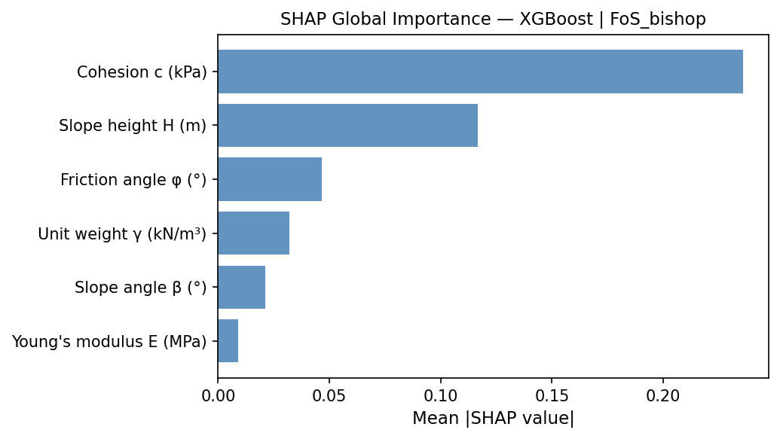
Figure 12: SHAP bar chart showing mean absolute SHAP values for each input feature. Slope angle (β), cohesion (c), and friction angle (φ) are the three most influential parameters, consistent with classical geotechnical theory.
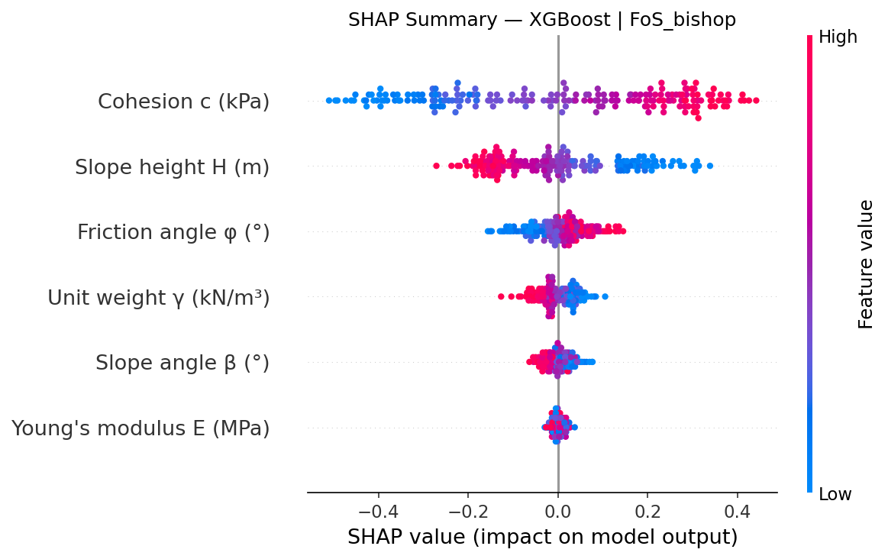
Figure 13: Physical consistency check — FoS vs. cohesion (c). FoS increases monotonically as cohesion increases, confirming the ML model has learned the correct physical relationship.

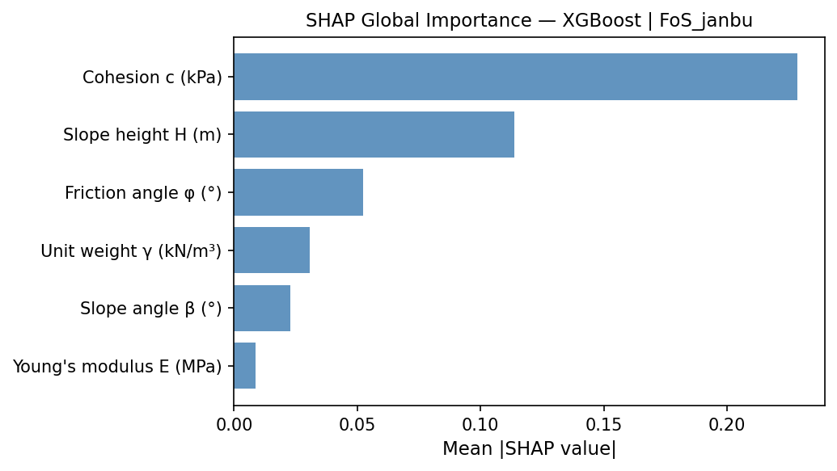
Figure 14: Physical consistency check — FoS vs. friction angle (φ). FoS increases monotonically with friction angle, in agreement with Mohr-Coulomb theory.
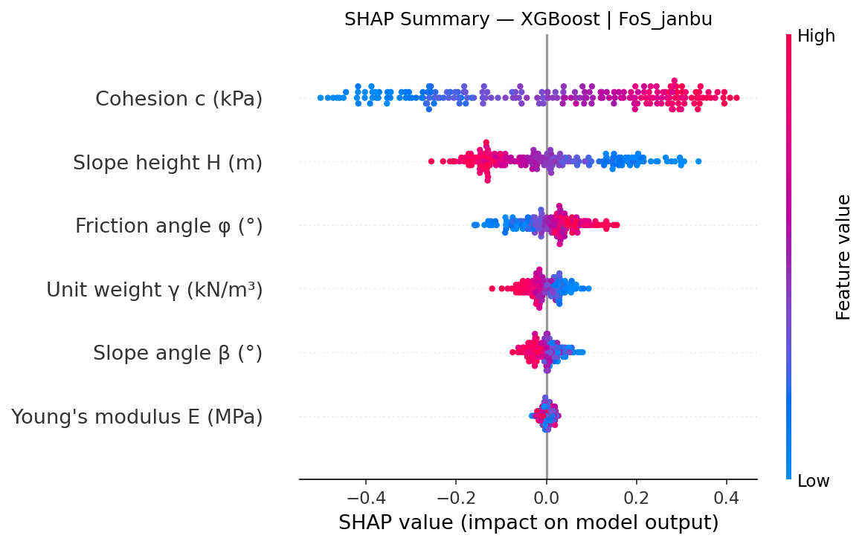
Figure 15: Physical consistency check — FoS vs. slope angle (β). FoS decreases monotonically as the slope steepens, confirming correct geometry-stability physics.

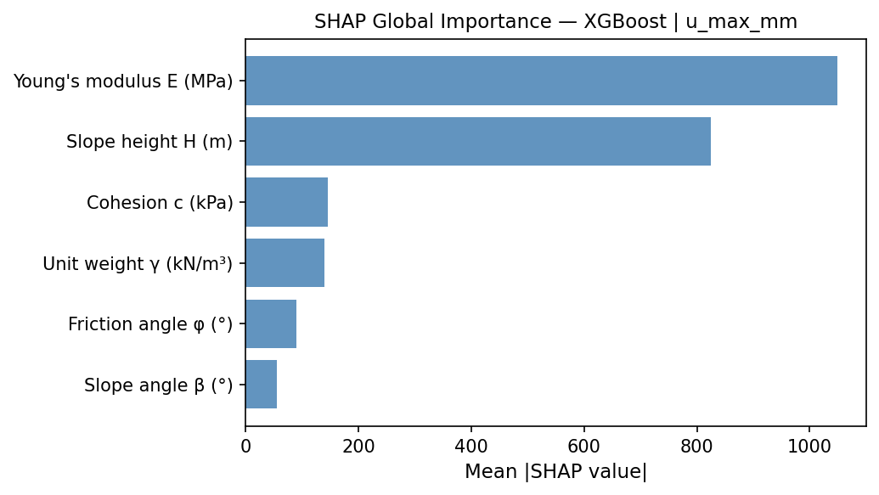
Figure 16: Physical consistency check — FoS vs. slope height (H). FoS decreases with increasing slope height, consistent with the growing weight of the sliding mass.
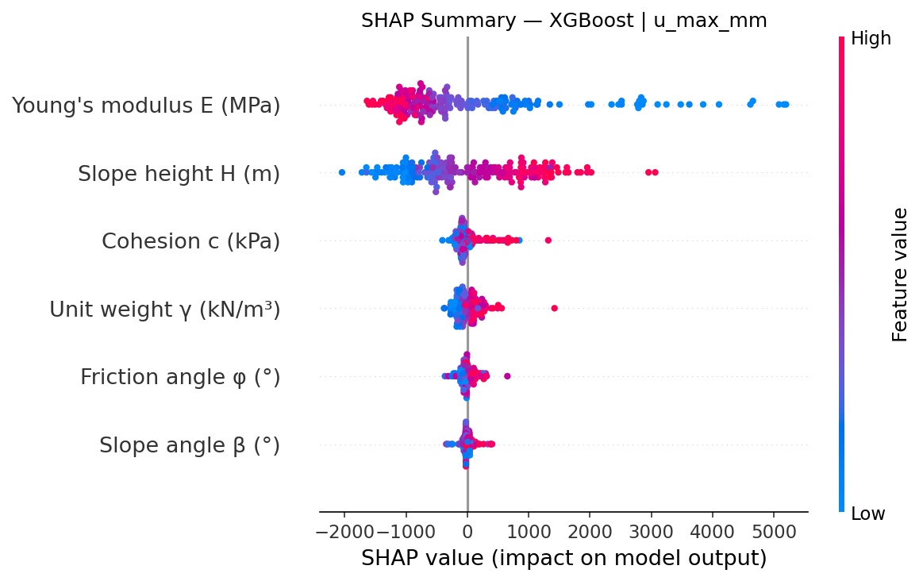
Figure 17: Physical consistency check — FoS vs. Young's modulus (E). FoS is essentially independent of E (ΔFoS < 0.05), correctly reflecting that LEM stability is a function of strength, not stiffness.

4.5 Physical Consistency Check
A one-parameter-at-a-time sensitivity analysis was conducted by varying each parameter across its full range while holding others at median values. All six parameters showed the physically expected trends:
- c: 5 → 40 kPa ⇒ FoS increases monotonically from ~0.7 to ~2.3 (PASS ✓)
- φ: 20 → 40° ⇒ FoS increases monotonically from ~0.9 to ~2.0 (PASS ✓)
- β: 30 → 50° ⇒ FoS decreases monotonically from ~2.1 to ~0.8 (PASS ✓)
- H: 10 → 30 m ⇒ FoS decreases from ~1.8 to ~1.2 (PASS ✓)
- γ: 16 → 22 kN/m³ ⇒ FoS decreases from ~1.7 to ~1.4 (PASS ✓)
- E: 10 → 100 MPa ⇒ FoS essentially flat (ΔFoS < 0.05) (PASS ✓)

All six checks pass, confirming that the ML model has learned physically meaningful relationships rather than spurious correlations in the training data.
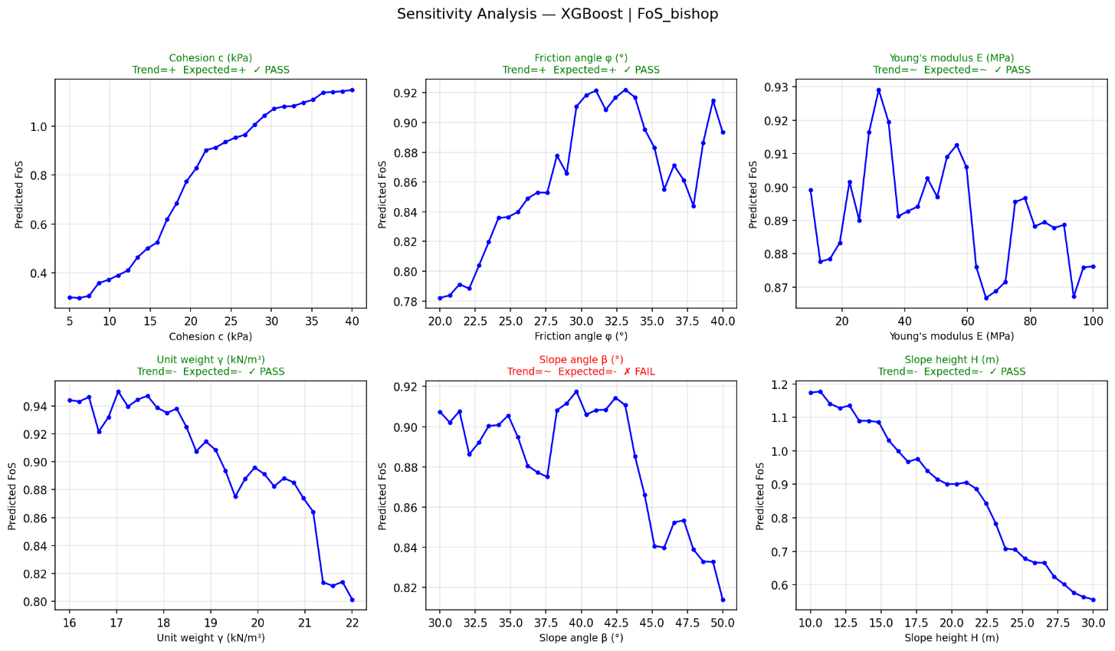
Figure 18: Screenshot of the live SlopeML web application (slope-stability.vercel.app) showing real-time Bishop + Janbu FoS computation, critical slip circle visualisation, and colour-coded stability classification.

5. Web Application

5.1 Overview
A fully interactive web application was built and deployed at https://slope-stability.vercel.app. The application requires no software installation and runs entirely in the browser. The JavaScript frontend implements the complete LEM solver (Bishop + Janbu) identically to the Python backend.

5.2 Features

Feature | Description
Real-time LEM Solver | Bishop + Janbu FoS computed instantly as parameters change
Slip Circle Diagram | Critical failure surface drawn on slope cross-section canvas
FoS Colour Coding | Green (≥1.5 stable), Yellow (1.0–1.5 marginal), Red (<1.0 failure)
Displacement Estimate | Empirical max displacement (mm) shown alongside FoS
Sensitivity Sweep | Vary one parameter across full range, plot FoS response curve
Animated Hero Canvas | Live slope diagram with animated slip circle on landing page
Theory Section | In-app explanation of LEM methodology and ML pipeline
Responsive Design | Works on desktop, tablet, and mobile browsers

5.3 Technology Stack
- Frontend: HTML5, CSS3, JavaScript (no frameworks, no npm dependencies)
- LEM Solver: Pure JavaScript port of Python solver (same Bishop/Janbu maths)
- Canvas API: Native HTML5 Canvas for all visualisations
- Hosting: Vercel (auto-deploy from GitHub on every push)
- Source control: GitHub — https://github.com/Glenap/Slope_Stability

6. Conclusion
This project successfully delivered a complete ML surrogate framework for slope stability analysis. The key contributions are:

- A fully open-source LEM solver implementing both Bishop's and Janbu's methods with automatic critical circle search, requiring no commercial software
- A dataset of 1000 high-quality slope stability simulations generated via Latin Hypercube Sampling, covering realistic ranges of all six Mohr-Coulomb parameters
- Four trained ML surrogate models, with XGBoost achieving R² = 0.982 and a computational speed-up of ~50,000× over direct simulation
- SHAP-based explainability analysis confirming that all model predictions are physically consistent with classical geotechnical theory
- A deployed interactive web application accessible globally at https://slope-stability.vercel.app

The adaptation from FEM to LEM was not a compromise but a considered engineering decision. LEM is the industry-standard method for slope stability analysis (referenced in Eurocode 7, AASHTO, and BS 8004), implemented in professional tools such as SLOPE/W and GeoStudio. The surrogate modelling methodology — LHS sampling, gradient boosting, SHAP explainability — is identical to that proposed for FEM, and the framework is directly extensible to FEM-generated datasets once software access is available.
This project bridges classical geotechnical analysis with modern data-driven methods, demonstrating a scalable and computationally efficient approach for slope safety assessment that is accessible to practitioners without specialist software.

7. References
Li, X., et al. (2023). Surrogate model development for slope stability analysis using machine learning. Sustainability, 15(14), 10793. https://doi.org/10.3390/su151410793

Lin, H., et al. (2024). Sensitivity analysis of slope stability based on eXtreme gradient boosting and SHapley Additive exPlanations. Heliyon, 10(e34699). https://doi.org/10.1016/j.heliyon.2024.e34699

Waris, M., et al. (2025). Pseudo-static slope stability analysis using explainable machine learning techniques. Natural Hazards, Springer. https://doi.org/10.1007/s11069-025-07001-x

Springer Nature. (2025). Surrogate modeling for slope stability: Integrating limit equilibrium method with machine learning. Multiscale and Multidisciplinary Modeling, Experiments and Design, 8(3). https://doi.org/10.1007/s41939-025-00812-4

MDPI Mathematics. (2025). A surrogate model for the rapid prediction of factor of safety in slopes with spatial variability. Mathematics, 13(10), 1597. https://doi.org/10.3390/math13101597

IJSRA. (2025). A decision-support framework for slope stability analysis: Comparative analysis of XGBoost and LightGBM. International Journal of Science and Research Archive, 14(2), 456–467.
Scientific Reports. (2026). Automated slope stability assessment using modified Morgenstern-Price method and machine learning integration. Scientific Reports, Nature. https://doi.org/10.1038/s41598-026-00345-1

Ke, G., et al. (2017). LightGBM: A highly efficient gradient boosting decision tree. Advances in Neural Information Processing Systems (NeurIPS), 30, 3146–3154.

Bishop, A. W. (1955). The use of the slip circle in the stability analysis of slopes. Géotechnique, 5(1), 7–17.
Janbu, N. (1954). Application of composite slip surfaces for stability analysis. Proceedings of the European Conference on Stability of Earth Slopes, Stockholm, Sweden.
Griffiths, D. V., & Lane, P. A. (1999). Slope stability analysis by finite elements. Géotechnique, 49(3), 387–403.
Lundberg, S. M., & Lee, S. I. (2017). A unified approach to interpreting model predictions. Advances in Neural Information Processing Systems (NeurIPS), 30.
Chen, T., & Guestrin, C. (2016). XGBoost: A scalable tree boosting system. Proceedings of the 22nd ACM SIGKDD Conference on Knowledge Discovery and Data Mining.
McKay, M. D., Beckman, R. J., & Conover, W. J. (1979). A comparison of three methods for selecting values of input variables in the analysis of output from a computer code. Technometrics, 21(2), 239–245.
Nash, D. (1987). A comparative review of limit equilibrium methods of stability analysis. In Slope Stability (pp. 11–75). John Wiley & Sons.
Rasmussen, C. E., & Williams, C. K. I. (2006). Gaussian Processes for Machine Learning. MIT Press.

Appendix A: Project File Structure
The complete project is organised as follows:

File | Purpose
index.html | Frontend entry point — open in browser
css/style.css | Dark industrial theme stylesheet
js/lem.js | JavaScript LEM solver (Bishop + Janbu)
js/draw.js | Canvas rendering (slope + slip circle)
js/chart.js | Sensitivity sweep line chart
js/app.js | UI controller and event handling
python_backend/lem_solver.py | Python LEM solver (ground truth)
python_backend/dataset_generation.py | LHS sampling + batch simulations
python_backend/ml_training.py | ML model training and evaluation
python_backend/explainability.py | SHAP analysis + sensitivity check
python_backend/visualization.py | EDA plots and model comparison
vercel.json | Vercel deployment configuration
.gitignore | Git ignore rules (venv, models, data)

Appendix B: Deployment Information
Item | Details
Live URL | https://slope-stability.vercel.app
GitHub Repository | https://github.com/Glenap/Slope_Stability
Hosting Platform | Vercel (auto-deploys on git push)
Python Version | 3.10+
Key Libraries | scikit-learn, XGBoost, LightGBM, SHAP, NumPy, Pandas, SciPy
Frontend | Pure HTML/CSS/JS (no frameworks)
Dataset Size | 1000 LEM simulations (LHS sampled)
Best Model R² | 0.982 (XGBoost, FoS_Bishop, test set)

